March Newsletter
Sunday Services
Please note: services are at 11 a.m. All are welcome.
We would be grateful if you would switch your phones to airplane mode before the start of the service.
03rd March - Anthea Ballam, member and Interfaith Minister
Organist Maurice Rigby
10th March - Stephen Crowther, Lay Pastor, Hastings
Pianist Pamela Nickels
17th March Equinox Service
Jef Jones, Lay Pastor, Brighton Unitarian Church
Pianist Kathy Pitt
24th March - Jo O'Sullivan, member
Pianist Stuart Deeks
31st March - Rev Maria Curtis, Horsham
Pianist Joe Ward

Quiet Reflection Circle 7 - 8 pm, Thursday 14th March
See below for more information.

Welcome from Jef
Welcome to the Newsletter for March.
You'll also see below information about three concerts in April. Two of them are raising funds for our church - thank you Matthew Sear, Timi Mohai, J.P. Brzechwa and the Beaufort String Quartet. The other concert this month is raising money for the Peter Tatchell Foundation, which does excellent work around the world promoting and protecting human rights.
You will also see that at our service on March 17th we'll be celebrating the Spring Equinox. As always members of the congregation are invited to contribute to the service. You might like to share a few thoughts or a short reading which speaks to you of the time of year. You might like to bring something from your garden or from the natural world that symbolises the spring equinox for you. Everyone is welcome!
With best wishes, Jef Jones
From the Lay Leader
when the lithe water turns
and its tongue flatters the ferns
do you speak this kind of sound:
whirlpool whisking round?
from Dart by Alice Oswald
I've been reading a wonderful book called Dart by the poet Alice Oswald. It is one long poem, a hymn of praise to the river Dart in Devon, following it from its source in the moors to the English Channel. Alice Oswald spent several years being with the river, and talking to the people whose lives are bound up with it. Their stories, and sometimes their actual words, are woven into the work. There are ferrymen, poachers, bailiffs, fishermen and canoeists. People such as these are placed alongside local gods and river spirits, and all are interspersed with the natural life of the river, with the many plants and creatures whose lives are dependent on it. Over the course of the poem the river reveals itself as ancient, changeable, powerful, and in all kinds of way, alive.
This remarkable poem has reminded me of the beauty and wisdom of Daoism, an ancient Chinese philosophy. Daoism is associated with the writings of Laozi, a semi-mythical philosopher, who described the spiritual life as the Way, imagining its fluidity as a kind of river, a constantly changing current of energy and experience. Daoism advises us to pay close attention to the natural world, but to do as little as possible to interfere in it. Excessive desire and self-assertion are seen to be contradictory to the natural way of human life - which is simple and spontaneous.
There is no static, central god in Daoism but rather a single source of all things. Laozi calls this infinite, singular mystery the One or the Mother. No-one has found any historical evidence for the existence of person called Laozi, which means simply 'old person'. It may be that his great work the Tao Te Ching is a collection of sayings from different sources, or perhaps Laozi followed his own teaching of modesty and wanted to vanish after his death into mystery.
It might seem like a rather esoteric branch of mysticism, yet the precepts of Daoism influenced Chinese law and government. Like so many eastern traditions it encouraged the practices of stillness and kindness, and reminds us today, like Alice Oswald's poem, of some timeless truths. The world, of course, is always changing; some change is positive and some negative but the last few years have seen rapid disruption in political and civic life. There is a kind of harsh and scathing quality to a lot of public discourse, much of it it driven by social media and new technologies. In this context I find the words of the Tao Te Ching reassuring. Laozi wrote Nothing in the world is softer or weaker than water, and yet for attacking things that are firm and hard, nothing is so effectual. Everyone knows that the soft overcomes the hard and that gentleness conquers the strong, but few can carry it out. Here is perspective and wisdom for our difficult days.
Finally a few uplifting and timely words on a theme of rivers;
Even in the terror
There is love, twisted round
And round, Set it free.
River flow to the sea.
from The World is Rich, Ben Okri

Heart and Soul Gatherings in March

This month's Heart and Soul gatherings are as follows:
7pm, Thurs 7th March
7pm, Thurs 21st March
7pm, Thurs 28th March
Heart and Soul gatherings are an opportunity for us to come together as a congregation during the week. There is a time of reflection and stillness and we go on to explore different aspects of our spiritual lives together. Refreshments are available from 6.30 pm and the meetings start at 7pm. Everyone is welcome! If you would like to lead a gathering of Heart and Soul, or suggest a topic for discussion you are also welcome.

Quiet Reflective Circle
14th March, 7pm
On the second Thursday of each month we gather for candle lighting and quiet reflection. This starts at 7pm and lasts no longer than an hour. There will be readings, time for candle- lighting, stillness and a few simple closing words.
If you’ve been having a busy week, and could do with some stillness, do come along. If you’re looking for a time and place to reconnect with your spirit, do come along. If you’d like to sit quietly in a sacred place, please do come along. All are welcome!

Love, Loss and Remembrance
A six week programme exploring the spiritual dimensions of loss.
Grief holds hands with life. Life holds hands with grief.
Mark Belletini
To be alive and to be touched by other people’s lives is a precious gift. When we lose someone we love and who has loved us, inside our sorrow there are questions: What does it mean to continue to love that person? What meaning can we make out of our loss? How do we honour those we have lost - in our souls, and in the way we live our lives? What love will we ourselves leave behind? In a safe and creative group setting we will work with our shared experience of loss and look for the treasure within it. We will explore together how lamenting, commemorating and honouring might make our lives more meaningful and more beautiful.
Last year I co-created this course for Unitarian Summer School with Rev Danny Crosby, which due to ill health, I was unable to attend. However I'm pleased to be able to offer a version of the programme that Danny and I put together at our church in Brighton.
The programme will run on Wednesday afternoons in the church and is free. If you are interested in attending please do let me know. There will be 8 places only. Dates are as follows:
March 13th 1.30 - 5pm
March 20th 1.30 - 5pm
March 27th 1.30 - 5pm
April 3rd 1.30 - 5pm
April 10th 1.30 - 5pm
April 17th 1.30 - 5pm
Facilitator Jef Jones

Message from Anne
Anne has asked that we pass on thanks from Rev Ken Thom. He sells postcards for the Aviation Fellowship and, in the last year, BUC has contributed to a final sum of £17,846. In total, Rev Thom has raised in excess of £200,000. The fellowship delivers medical assistance to especially remote parts of rural Africa.
Postcards, new or used, on any subject, from anywhere in the world, are of value. If you have any cards please leave them in Anne's Treasure Box in the vestry.
Thank you.
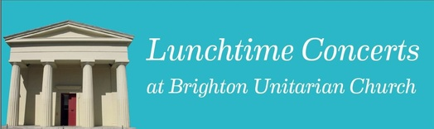
March
01st: Lucy Mair (soprano) and Helen Ridout (piano) perform Lieder by Schumann, Strauss and Brahms. To include Schumann's "Frauenliebe und Leben"
08th: Plaegan Piano Trio. Josef Haydn's charming Piano Trio in E minor, Hob. XV:12 is followed by Friedrich Smetana's dramatic and poignant Piano Trio in G minor, Op.15
15th: The LIPS Wind Quintet is delighted to return to Brighton Unitarian. As ever, we will bring a mellifluous murmuration of magical motifs and melodies to help lift you from your March maladies.
22nd: Brian Ashworth & Jon Rattenbury play an exciting and eclectic mix of music for two guitars. The duo will be playing a completely new programme which includes Spanish, Latin American and contemporary works.
29th: Canciones' - Spanish colour and fire from Manuel de Falla, plus piano music from Chopin and others and more vocal surprises! Eva Rustige (soprano) and Joe Ward (piano).
Doors and coffee from 12 noon.
Concert 12.30 – 1.15 p.m.
Ticket £4 on the door.

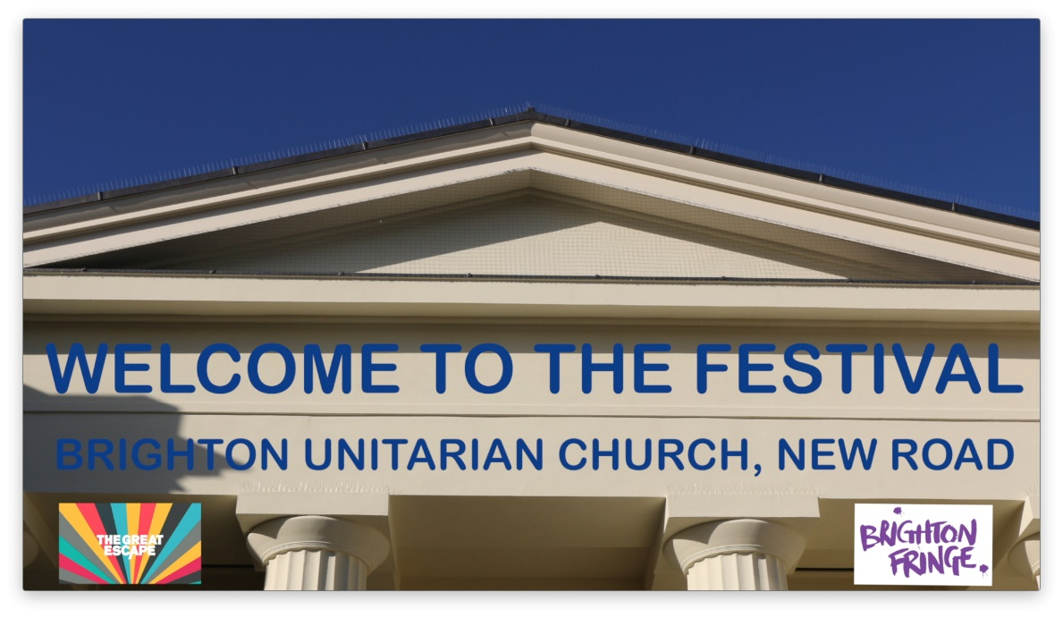
Friday 3rd May to Sunday 2nd June 2019
We have a really exciting programme of events booked for this May - Brighton Fringe, The Great Escape and lots of independent arts and music performances, plus our regular Friday lunchtime concerts. All the details are on our website http://www.brightonunitarian.org.uk/may-festival.html

YouTube Channel
Brighton Unitarian now has a YouTube channel. Do take the time to have a look, here is the link:
https://www.youtube.com/channel/UCT1m35I-Urvbyg2AsRRsF9g

Dates for Your Diary
Saturday 16th March, 11.30 a.m. to 5 p.m. SpringFest: in support of WaterAid and Amnesty International. Free event - everyone welcome. Live music, children's activities, games, cakes, Pimms, book stall, raffle.

Friday and Saturday, 22nd and 23rd March, 7.30 p.m. 'Keep Smiling Through: 1940s Wartime Britain in Songs and Sketches'. The Horsham Unity Players are back for their 6th year! Horsham Unitarian Church, Worthing Road, Horsham. Tickets and refreshments afterwards are free. There will be a retiring collection for the Church's charities.
Sunday 7th April, 2.30 p.m. Matthew Sear, Classical Guitar Recital. This is a fundraising concert for our church. Please do come along. It is really important that we support Matthew. There will be tea and cake. If you can make or bring in a cake please let Helen Lee or Jeannette Webb know in advance. Thank you.
Thursday 25th April, 6.30 p.m. Pergolesi: Stabat Mater - Timi Mohai (soprano), Jean-Pierre Brzechwa (counter tenor) and the Beaufort String Quartet. Donations to BUC's Building Appeal Fund.
Friday 26th April, 7.30 p.m. A Night of 21st Century Folk Music. Fundraising concert for the Peter Tatchell Foundation. Tickets £16 from Resident Records or on the door.

To keep up-to-date with all that is happening at Brighton Unitarian visit our website www.brightonunitarian.org.uk or follow us on:
Twitter: @BrightUnitarian
Facebook: https://www.facebook.com/BrightonUnitarian/
Instagram: https://www.instagram.com/brightonunitarianchurch/
YouTube:https://www.youtube.com/channel/UCT1m35I-Urvbyg2AsRRsF9g

